NAME – TUSHAR GOEL

REGISTRATION NUMER – 19BCE2185

COURSE CODE – CSE1004

SUBJECT – Network and Communication

LAB

SLOT – L25+L26

SUBJECT TEACHER – Ms. Santhi H Ma’am

ASSIGNMENT -3

1. **Write a menu driven code for Decimal, Binary**

**a) To check the class, network id and host id of an IPv4 address. (Use function wherever necessary)**

**b)To check whether given IP address is valid or not.**

**c) To find first address, last address and number of addresses in the block.**

**Aim:**

To check for Validity, Class, Network ID, Host ID, First Address, Last Address and Number of Addresses of a user input IPv4 Address

**Algorithms:**

**• Validity:**

Each Byte of an IPv4 Address must be between 0 and 255 (0-11111111 if binary) and there should be exactly 4 such bytes.

**• Class:**

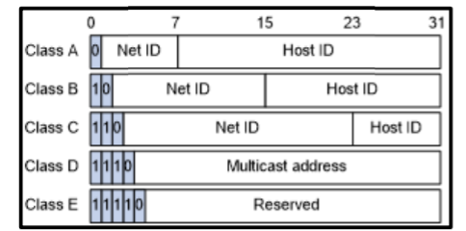

**Class A :** First Byte must be between 0 and 127 or start with 0 if binary input.

**Class B :** First Byte must be between 128 and 191 or start with 10 if binary input.

**Class C :** First Byte must be between 192 and 223 or start with 110 if binary input.

**Class D :** First Byte must be between 224 and 239 or start with 1110 if binary input.

**Class E :** First Byte must be between 240 and 255 or start with 11111 if binary input.

• **Network ID/Host ID:**

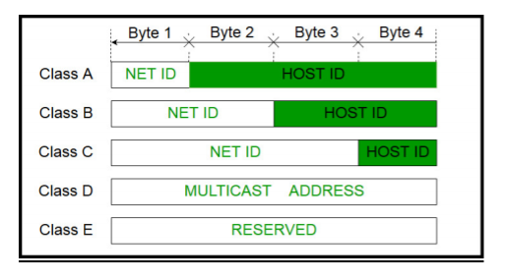

**Class A :** First Byte is the Network ID, rest is Host ID.

**Class B :** First and Second is Network ID, rest is Host ID.

**Class C :** First, second and third bytes is Network ID, rest is Host ID.

**Class D :** Multicast Addresses.

**Class E :** Reserved Addresses.

**• First/Last Addresses:**

**Class A :** First Address is 0.0.0.0 Last Address is 127.255.255.255

**Class B :** First Address is 128.0.0.0 Last Address is 191.255.255.255

**Class C :** First Address is 192.0.0.0 Last Address is 223.255.255.255

**Class D :** Invalid as there is no subnet.

**Class E :** Invalid as there is no subnet.

**Menu-Driven Source Code:**

#include<bits/stdc++.h>

using namespace std;

int DecimalOrBinary();

void DecimalIPClass();

bool ValidIP(string,int);

void DecimalFirstLast();

void BinaryIPClass();

int toDecimal(string);

void BinaryFirstLast();

void IPClassMenu()

{

int decimalBinary=DecimalOrBinary();

switch(decimalBinary)

{

case 1:

DecimalIPClass();

break;

case 2:

BinaryIPClass();

break;

}

cout<<"\n\n\n\n";

}

void DecimalIPClass()

{

start:

string ip;

cout<<"Enter the IP Address(In Decimal): ";

cin>>ip;

if(ValidIP(ip,1))

{

string block1="";

string block2="";

string block3="";

string block4="";

int i=0;

while(ip[i]!='.')

{

block1.push_back(ip[i]);

i++;

}

i++;

while(ip[i]!='.')

{

block2.push_back(ip[i]);

i++;

}

i++;

while(ip[i]!='.')

{

block3.push_back(ip[i]);

i++;

}

i++;

while(ip[i])

{

block4.push_back(ip[i]);

i++;

}

if(stoi(block1)<=127)

{

cout<<"\nClass: Class A\nNetwork ID: "<<block1<<"\nHost ID: "<<block2<<"."<<block3<<"."<<block4;

}

else if(stoi(block1)>=128 && stoi(block1)<=191)

{

cout<<"\nClass: Class B\nNetwork ID: "<<block1<<"."<<block2<<"\nHost ID: "<<block3<<"."<<block4;

}

else if(stoi(block1)>=192 && stoi(block1)<=223)

{

cout<<"\nClass: Class C\nNetwork ID: "<<block1<<"."<<block2<<"."<<block3<<"\nHost ID: "<<block4;

}

else if(stoi(block1)>=224 && stoi(block1)<=239)

{

cout<<"\nClass: Class D";

}

else

{

cout<<"\nClass: Class E";

}

}

else

{

cout<<"\nEnter a valid IP Address.\n";

goto start;

}

}

void BinaryIPClass()

{

start:

string ip;

cout<<"Enter the IP Address (In Binary): ";

cin>>ip;

if(ValidIP(ip,2))

{

string block1="";

string block2="";

string block3="";

string block4="";

int i=0;

while(ip[i]!='.')

{

block1.push_back(ip[i]);

i++;

}

i++;

while(ip[i]!='.')

{

block2.push_back(ip[i]);

i++;

}

i++;

while(ip[i]!='.')

{

block3.push_back(ip[i]);

i++;

}

i++;

while(ip[i])

{

block4.push_back(ip[i]);

i++;

}

if(toDecimal(block1)<=127)

{

cout<<"\nClass: Class A\nNetwork ID: "<<block1<<"\nHost ID: "<<block2<<"."<<block3<<"."<<block4;

}

else if(toDecimal(block1)>=128 && toDecimal(block1)<=191)

{

cout<<"\nClass: Class B\nNetwork ID: "<<block1<<"."<<block2<<"\nHost ID: "<<block3<<"."<<block4;

}

else if(toDecimal(block1)>=192 && toDecimal(block1)<=223)

{

cout<<"\nClass: Class C\nNetwork ID: "<<block1<<"."<<block2<<"."<<block3<<"\nHost ID: "<<block4;

}

else if(toDecimal(block1)>=224 && toDecimal(block1)<=239)

{

cout<<"\nClass: Class D is for Multicast Addresses";

}

else

{

cout<<"\nClass: Class E is for Reserved Addresses";

}

}

else

{

cout<<"\nEnter a valid IP Address.\n";

goto start;

}

}

int toDecimal(string s)

{

return stoi(s,0,2);

}

bool ValidIP(string ip, int decimalBinary)

{

int j=0;

int dots=0;

while(ip[j])

{

if(!isdigit(ip[j]) && ip[j]!='.')

return false;

if(ip[j]=='.')

dots++;

j++;

}

string block1="";

string block2="";

string block3="";

string block4="";

int i=0;

while(ip[i]!='.' && i<ip.length())

{

block1.push_back(ip[i]);

i++;

}

i++;

while(ip[i]!='.' && i<ip.length())

{

block2.push_back(ip[i]);

i++;

}

i++;

while(ip[i]!='.' && i<ip.length())

{

block3.push_back(ip[i]);

i++;

}

i++;

while(ip[i])

{

block4.push_back(ip[i]);

i++;

}

int flag=0;

if(decimalBinary==1)

{

if(dots==3 && !block1.empty() && !block2.empty() && !block3.empty() && !block4.empty())

{

if(stoi(block1)>=0 && stoi(block1)<=255)

{

if(stoi(block2)>=0 && stoi(block2)<=255)

{

if(stoi(block3)>=0 && stoi(block3)<=255)

{

if(stoi(block4)>=0 && stoi(block4)<=255)

{

flag=1;

return true;

}

}

}

}

}

if(flag==0)

{

return false;

}

}

else if(decimalBinary==2)

{

int k=0,flag1=0;

while(ip[k])

{

if(ip[k]!='1' && ip[k]!='0' && ip[k]!='.')

{

return false;

}

k++;

}

if(dots==3 && !block1.empty() && !block2.empty() && !block3.empty() && !block4.empty())

{

if(toDecimal(block1)>=0 && toDecimal(block1)<=255)

{

if(toDecimal(block2)>=0 && toDecimal(block2)<=255)

{

if(toDecimal(block3)>=0 && toDecimal(block3)<=255)

{

if(toDecimal(block4)>=0 && toDecimal(block4)<=255)

{

flag1=1;

return true;

}

}

}

}

if(flag1==0)

{

return false;

}

}

else

{

return false;

}

}

}

int DecimalOrBinary()

{

start:

int choice;

cout<<"1.Decimal\n2.Binary\nEnter your choice: ";

cin>>choice;

cout<<"\n\n";

switch(choice)

{

case 1:

return 1;

case 2:

return 2;

default:

cout<<"\nInvalid Choice\n";

goto start;

}

}

void ValidIPMenu()

{

int decimalBinary=DecimalOrBinary();

if(decimalBinary==1)

{

cout<<"Enter Decimal IP Address: ";

}

if(decimalBinary==2)

{

cout<<"Enter Binary IP Address: ";

}

string ip;

cin>>ip;

bool isvalid=ValidIP(ip,decimalBinary);

if(isvalid)

{

cout<<"\nThe input IP Address is VALID.\n";

}

else

{

cout<<"\nThe input IP Address is INVALID\n";

}

cout<<"\n\n\n\n";

}

void FirstLastMenu()

{

int decimalBinary=DecimalOrBinary();

switch(decimalBinary)

{

case 1:

DecimalFirstLast();

break;

case 2:

BinaryFirstLast();

break;

}

cout<<"\n\n\n\n";

}

void DecimalFirstLast()

{

start:

string ip;

cout<<"\nEnter the Decimal IP Address: ";

cin>>ip;

if(ValidIP(ip,1))

{

string block1="";

string block2="";

string block3="";

string block4="";

int i=0;

while(ip[i]!='.')

{

block1.push_back(ip[i]);

i++;

}

i++;

while(ip[i]!='.')

{

block2.push_back(ip[i]);

i++;

}

i++;

while(ip[i]!='.')

{

block3.push_back(ip[i]);

i++;

}

i++;

while(ip[i])

{

block4.push_back(ip[i]);

i++;

}

if(stoi(block1)<=127)

{

cout<<"First Address: "<<block1<<".0.0.0\nLast Address: "<<block1<<".255.255.255\nNumber of Addresses: "<<(long long int)pow(2,24);

}

else if(stoi(block1)>=128 && stoi(block1)<=191)

{

cout<<"First Address: "<<block1<<"."<<block2<<".0.0\nLast Address: "<<block1<<".255.255\nNumber of Addresses: "<<(long long int)pow(2,16);

}

else if(stoi(block1)>=192 && stoi(block1)<=223)

{

cout<<"First Address: "<<block1<<"."<<block2<<block3<<".0\nLast Address: "<<block1<<".255\nNumber of Addresses: "<<pow(2,8);

}

else if(stoi(block1)>=224 && stoi(block1)<=239)

{

cout<<"First Address: Invalid\nLast Address: Invalid\nNumber of Addresses: Invalid";

}

else if(stoi(block1)>=240 && stoi(block1)<=255)

{

cout<<"First Address: Invalid\nLast Address: Invalid\nNumber of Addresses: Invalid";

}

}

else

{

cout<<"\nEnter a valid IP Address.\n";

goto start;

}

}

void BinaryFirstLast()

{

start:

string ip;

cout<<"\nEnter the Decimal IP Address: ";

cin>>ip;

if(ValidIP(ip,2))

{

string block1="";

string block2="";

string block3="";

string block4="";

int i=0;

while(ip[i]!='.')

{

block1.push_back(ip[i]);

i++;

}

i++;

while(ip[i]!='.')

{

block2.push_back(ip[i]);

i++;

}

i++;

while(ip[i]!='.')

{

block3.push_back(ip[i]);

i++;

}

i++;

while(ip[i])

{

block4.push_back(ip[i]);

i++;

}

if(toDecimal(block1)<=127)

{

cout<<"First Address: "<<block1<<".0.0.0\nLast Address: "<<block1<<".11111111.11111111.11111111\nNumber of Addresses: "<<(long long int)pow(2,24);

}

else if(toDecimal(block1)>=128 && toDecimal(block1)<=191)

{

cout<<"First Address: "<<block1<<"."<<block2<<".0.0\nLast Address: "<<block1<<".11111111.11111111\nNumber of Addresses: "<<(long long int)pow(2,16);

}

else if(toDecimal(block1)>=192 && toDecimal(block1)<=223)

{

cout<<"First Address: "<<block1<<"."<<block2<<block3<<".0\nLast Address: "<<block1<<".11111111\nNumber of Addresses: "<<pow(2,8);

}

else if(toDecimal(block1)>=224 && toDecimal(block1)<=239)

{

cout<<"First Address: Invalid\nLast Address: Invalid\nNumber of Addresses: Invalid";

}

else

{

cout<<"First Address: Invalid\nLast Address: Invalid\nNumber of Addresses: Invalid";

}

}

else

{

cout<<"\nEnter a valid IP Address.";

goto start;

}

}

void options()

{

while(true)

{

cout<<" ****** IPv4 Addressing Main Menu *****\n\n\n";

cout<<"1. To check the class, network id and host id of an IPv4 address\n2.To check whether given IP address is valid or not\n3.To find first address, last address and number of addresses in the block\n4. Exit\n\nEnter your choice: ";

int choice;

cin>>choice;

cout<<"\n\n";

switch(choice)

{

case 1:

IPClassMenu();

break;

case 2:

ValidIPMenu();

break;

case 3:

FirstLastMenu();

break;

case 4:

exit(0);

break;

default:

cout<<"\nInvalid Choice\n";

break;

}

}

}

int main()

{

system("cls");

options();

return 0;

}

**OUTPUT SCREENSHOTS:**

1. **To check the class, network id and host id of an IPv4 address :**
2. **Decimal IP:**

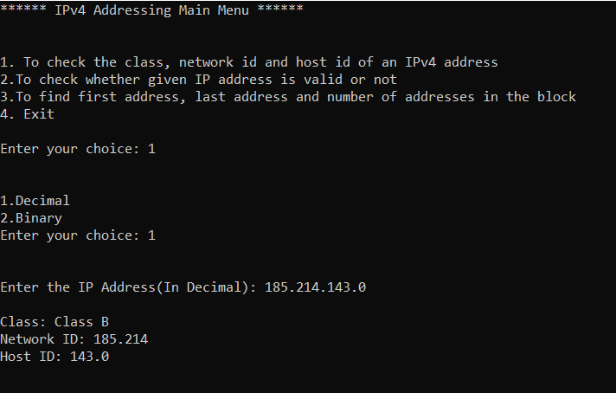

**ii. Binary IP:**

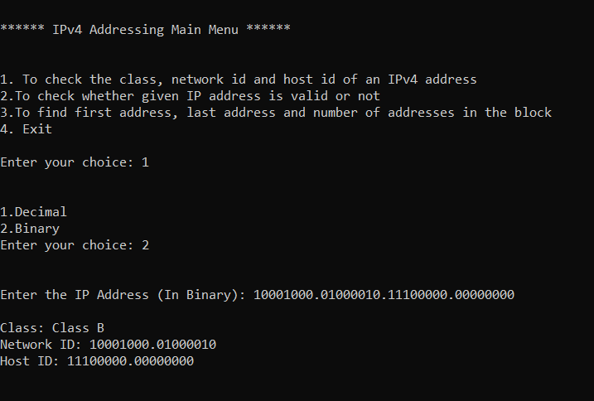

1. **To check whether given IP address is valid or not :**

**i. Decimal IP:**

**• Invalid:**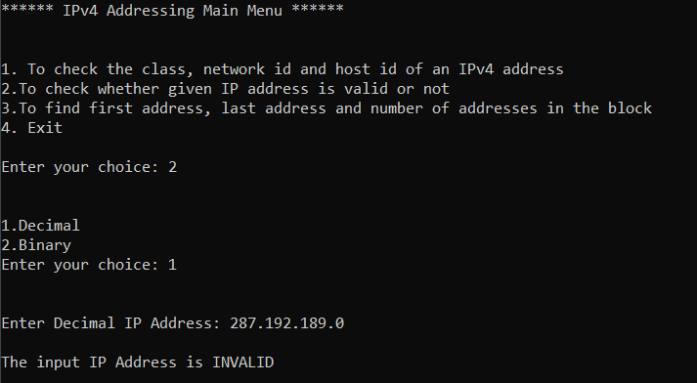

**(It is invalid because the first Byte is greater than 255)**

**• Valid:** 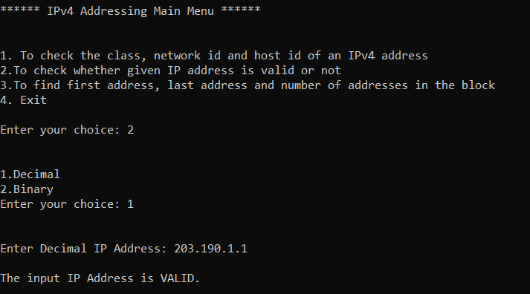

1. **Binary IP:**

**• Invalid:**

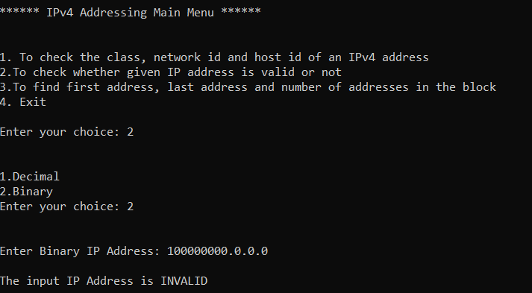

**1 Byte = 1bits**

**(So the above IP Address in invalid because the first byte has greater than 8 bits)**

**• Valid:** 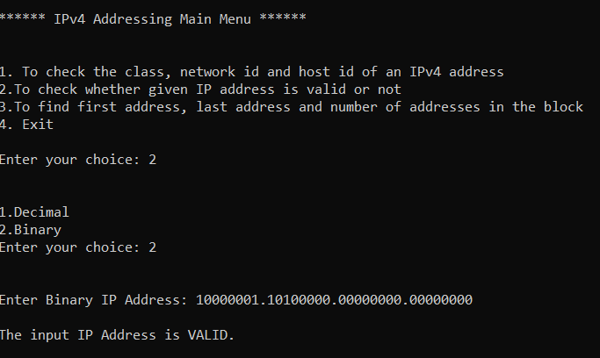

**c) To find first address, last address and number of addresses in the block :**

**i. Decimal IP:** 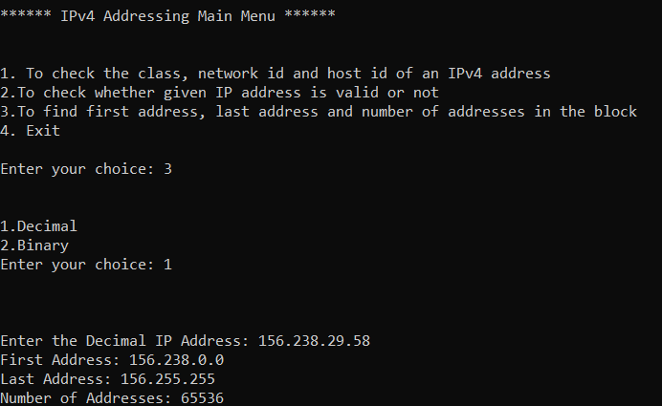

1. **Binary IP:**

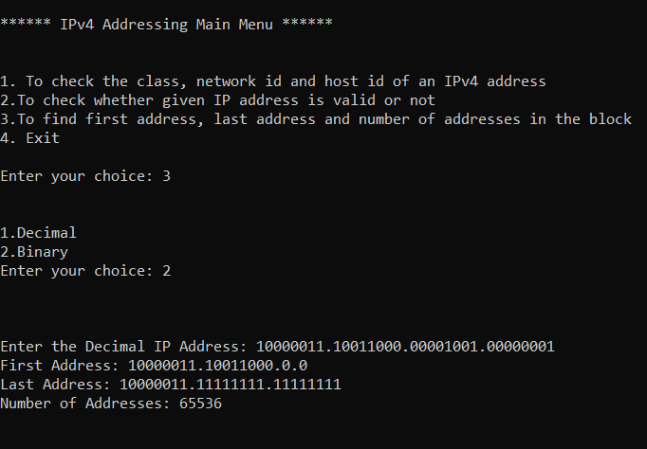

1. **Implement the following unicast routing algorithms using functions.**

**a. Distance Vector Routing**

**b. Link State Routing**

**Aim:**

To implement Distance Vector and Link State Routing Techniques in C++.

**Algorithms:**

1. **Distance Vector Routing:** 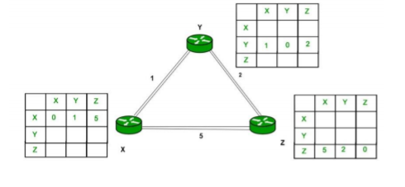

1. A router transmits its distance vector to each of its neighbours in a routing packet.

2. Each router receives and saves the most recently received distance vector from each of its neighbours.

3. A router recalculates its distance vector when:

• It receives a distance vector from a neighbour containing different information than before.

• It discovers that a link to a neighbour has gone down.

{

At each node x,

Initialization

for all destinations y in N:

Dx(y) = c(x,y) // If y is not a neighbor then c(x,y) = ∞

for each neighbor w

Dw(y) = ? for all destination y in N.

for each neighbor w

send distance vector Dx = [ Dx(y) : y in N ] to w

loop

wait(until I receive any distance vector from some neighbor w)

for each y in N:

Dx(y) = minv{c(x,v)+Dv(y)}

If Dx(y) is changed for any destination y

Send distance vector Dx = [ Dx(y) : y in N ] to all neighbors

Forever

}

1. **Link State Routing:**

**• Step-1:** The node is taken and chosen as a root node of the tree, this creates the tree with a single node, and now set the total cost of each node to some value based on the information in Link State Database

**• Step-2:** Now the node selects one node, among all the nodes not in the tree like structure, which is nearest to the root, and adds this to the tree. The shape of the tree gets changed .

**• Step-3:** After this node is added to the tree, the cost of all the nodes not in the tree needs to be updated because the paths may have been changed.

**• Step-4:** The node repeats the Step 2. and Step 3. until all the nodes are added in the tree

{

function dijkstra(G, S)

for each vertex V in G

distance[V] <- infinite

previous[V] <- NULL

If V != S, add V to Priority Queue Q

distance[S] <- 0

while Q IS NOT EMPTY

U <- Extract MIN from Q

for each unvisited neighbour V of U

tempDistance <- distance[U] + edge_weight(U, V)

if tempDistance < distance[V]

distance[V] <- tempDistance

previous[V] <- U

return distance[], previous[]

}

**Menu-Driven Source Code:**

#include<bits/stdc++.h>

#define INF 9999

#define MAX 10

using namespace std;

void LinkState();

void DistanceVector();

void DistanceVector()

{

int graph[50][50];

int i,j,k,t;

int nn;

cout<<"\n Enter Number of Nodes:";

cin>>nn;

for (i=0;i<nn;i++)

{

for(j=0;j<nn;j++)

{

graph[i][j]=-1;

}

}

char ch[7]={'A','B','C','D','E','F','G'};

for (i=0;i<nn;i++)

{

for(j=0;j<nn;j++)

{

if(i==j)

{

graph[i][j]=0;

}

if(graph[i][j]==-1)

{

cout<<"\n Enter Distance between "<<ch[i]<<" - "<<ch[j]<<" : ";

cin>>t;

graph[i][j]=graph[j][i]=t;

}

}

}

int via[50][50];

for (i=0;i<nn;i++)

{

for(j=0;j<nn;j++)

{

via[i][j]=-1;

}

}

cout<<"\n After Initialization";

for (i=0;i<nn;i++)

{

cout<<"\n"<<ch[i]<<" Table";

cout<<"\nNode\tDist\tVia";

for(j=0;j<nn;j++)

{

cout<<"\n"<<ch[j]<<"\t"<<graph[i][j]<<"\t"<<via[i][j];

}

}

int sh[50][50][50];

for(i=0;i<nn;i++)

{

for(j=0;j<nn;j++)

{

for (k=0;k<nn;k++)

{

if((graph[i][j]>-1)&&(graph[j][k]>-1))

{

sh[i][j][k]=graph[j][k]+graph[i][j];

}

else

{

sh[i][j][k]=-1;

}

}

}

}

for(i=0;i<nn;i++)

{

cout<<"\n\n For "<<ch[i];

for (j=0;j<nn;j++)

{

cout<<"\n From "<<ch[j];

for(k=0;k<nn;k++)

{

cout<<"\n "<<ch[k]<<" "<<sh[i][j][k];

}

}

}

int final[50][50];

for(i=0;i<nn;i++)

{

for(j=0;j<nn;j++)

{

final[i][j]=graph[i][j];

via[i][j]=i;

for(k=0;k<nn;k++)

{

if((final[i][j]>sh[i][k][j]) || (final[i][j] == -1))

{

if(sh[i][k][j]>-1)

{

final[i][j]=sh[i][k][j];

via[i][j]=k;

}

}

}

if(final[i][j]==-1)

{

for(k=0;k<nn;k++)

{

if((final[i][k]!=-1)&&(final[k][j]!=-1))

{

if((final[i][j]==-1) || ((final[i][j]!=-1) &&(final[i][j]>final[i][k]+final[k][j])))

{

if(final[i][k]+final[k][j]>-1)

{

final[i][j]=final[i][k]+final[k][j];

via[i][j]=k;

}

}

}

}

}

}

}

cout<<"\n After Update :";

for (i=0;i<nn;i++)

{

cout<<"\n"<<ch[i]<<" Table";

cout<<"\nNode\tDist\tVia";

for(j=0;j<nn;j++)

{

cout<<"\n"<<ch[j]<<"\t"<<final[i][j]<<"\t";

if(i==via[i][j])

cout<<"-";

else

cout<<ch[via[i][j]];

}

}

cout<<"\n\n-----------------------------\n\n";

}

void dijkstra(int G[MAX][MAX],int n,int startnode)

{

int cost[MAX][MAX],distance[MAX],pred[MAX];

int visited[MAX],count,mindistance,nextnode,i,j;

for(i=0;i<n;i++)

for(j=0;j<n;j++)

if(G[i][j]==0)

cost[i][j]=INF;

else

cost[i][j]=G[i][j];

for(i=0;i<n;i++)

{

distance[i]=cost[startnode][i];

pred[i]=startnode;

visited[i]=0;

}

distance[startnode]=0;

visited[startnode]=1;

count=1;

while(count<n-1)

{

mindistance=INF;

for(i=0;i<n;i++)

if(distance[i]<mindistance&&!visited[i])

{

mindistance=distance[i];

nextnode=i;

}

visited[nextnode]=1;

for(i=0;i<n;i++)

if(!visited[i])

if(mindistance+cost[nextnode][i]<distance[i])

{

distance[i]=mindistance+cost[nextnode][i];

pred[i]=nextnode;

}

count++;

}

for(i=0;i<n;i++)

if(i!=startnode)

{

if(distance[i]!=9999)

{

cout<<"\nDistance of the node "<<i<<" = "<<distance[i];

cout<<"\nPath = "<<i;

j=i;

do

{

j=pred[j];

cout<<"<-"<<j;

}while(j!=startnode);

cout<<"\n";

}

else

{

cout<<"\nDistance of the node "<<i<<" = INF";;

cout<<"\nNo path";

}

}

cout<<"\n\n\n";

}

void LinkState()

{

int G[MAX][MAX],i,j,n,u;

cout<<"Enter the number of vertices: ";

cin>>n;

cout<<"\nEnter the adjacency matrix:\n";

for(i=0;i<n;i++)

for(j=0;j<n;j++)

cin>>G[i][j];

while(true)

{

cout<<"\nEnter the source/start node: ";

cin>>u;

dijkstra(G,n,u);

}

}

int main()

{

system("cls");

while(true)

{

cout<<"**********Unicast Routing Main Menu**********\n\n\n";

cout<<"1.Distance Vector Routing\n2.Link State Routing\n0.Exit\nEnter your choice: ";

int choice;

cin>>choice;

cout<<"\n\n";

switch(choice)

{

case 1:

DistanceVector();

break;

case 2:

LinkState();

break;

case 0:

exit(0);

break;

default:

cout<<"\nInvalid Choice\n";

break;

}

}

}

**OUTPUT SCREENSHOTS:**

1. **Distance Vector Routing:**

**Input Graph:**

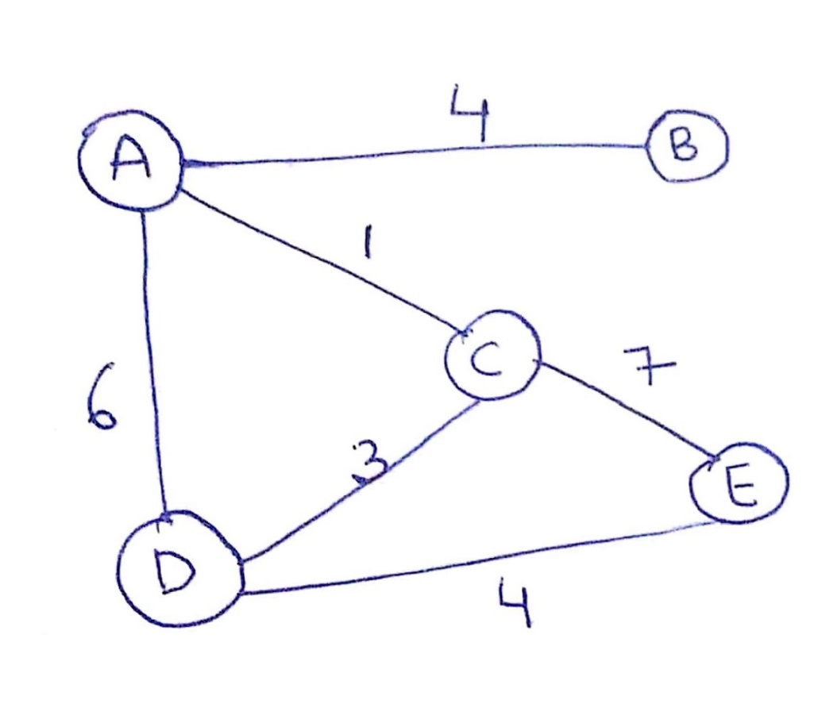

**Input :**

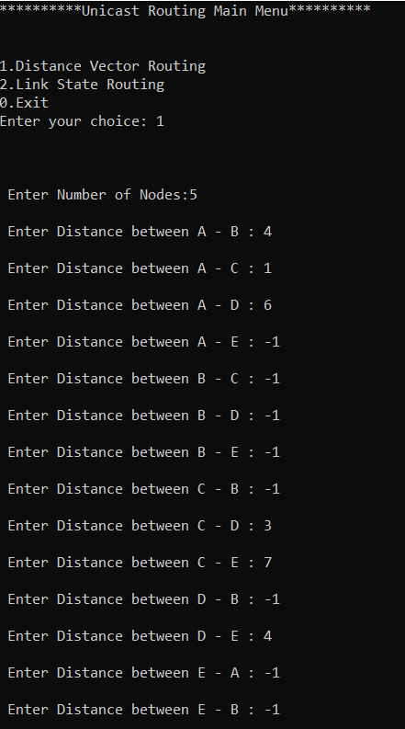

**After Initialization :**

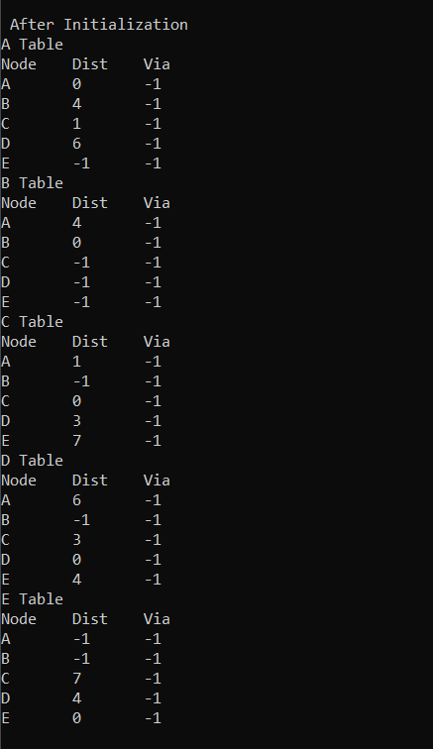

**After Updating :**

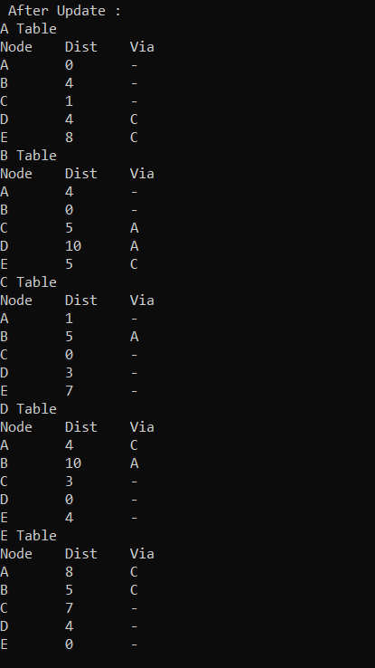

1. **Link State Routing:**

**Input Graph:**

